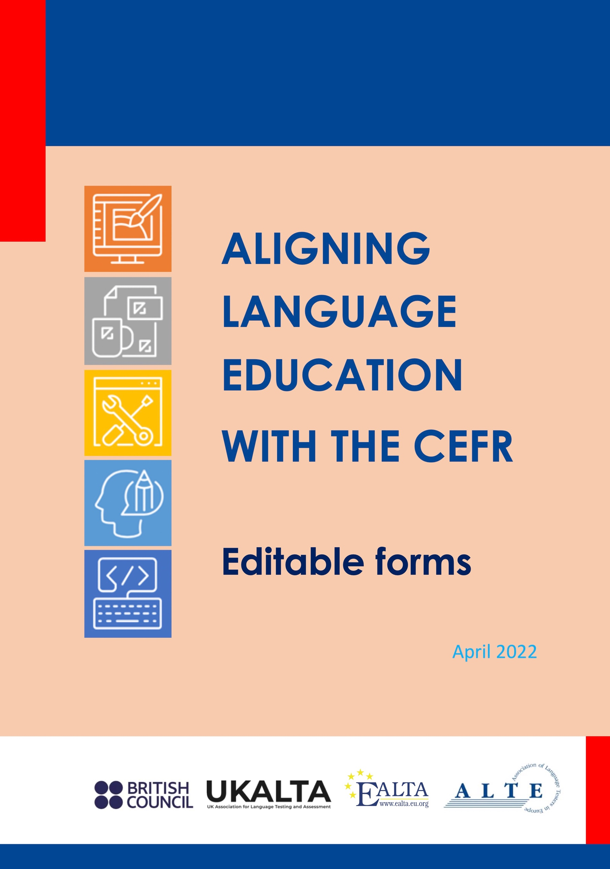

Aligning Language Education with the CEFR: A Handbook
These editable versions of the forms in the appendix to the handbook allow the forms to be used electronically and/or adapted to particular contexts.
The Handbook is published jointly by the European Association for Language Testing and Assessment (EALTA), the UK Association for Language Testing and Assessment (UKALTA), the British Council, and the Association for Language Testers in Europe (ALTE).
ISBN: 978-1-7397544-1-9
© British Council, UKALTA, EALTA and ALTE. 2022.

CONTENTS
Forms for Chapter 2: Familiarization 3
Form 2.1: Generic familiarization 3
Form 2.2: Specific familiarization, Session 1 5
Form 2.3: Overall summary of familiarization process 7
Forms for Chapter 3: Specification 9
Form 3.1: Description of the alignment and the resource 9
Form 3.2: Language activities, strategies, and competences 10
Form 3.3: Graphic profiling of alignment 11
Form 3.4: Illustrative descriptors of language activities and strategies 12
Form 3.5: Detailed mapping 13
Forms for Chapter 4: Standardization 14
Form 4.1: Standardization summary form – participant 14
Form 4.2: Standardization summary form – coordinator 16
Form 4.3: Analysis of illustrative examples. Holistic form 18
Form for Chapter 5: Standard setting 19

Forms for Chapter 2: Familiarization

Form 2.1: Generic familiarization
This Summary form shows that you have completed the activities proposed and your responses can be used for future reference, for validation and in reporting.
Name of user
Date
Name of institution
Title of resource
Type of resource |  | Curriculum |  | Course material
 |  | Textbook |  | Exam
 |  | Other: ________________________ (Please specify)
ACTIVITIES |  | Responses
1 | Chapters 1 & 2  - What does alignment to the CEFR mean?  - What can be the implications for me? And for my context?
2 | Section 2.4  - What are the competences, activities and strategies  most relevant in my context? Why?  - Are they all equally relevant? If not, how can I prioritize them?
3 | CEFR CV, Appendices 1 & 2  - What level(s) will I mainly be working with?  - Which are the main aspects in that level and in the adjacent  ones?  - Which aspects are most relevant in my context for each  mode of communication?
4 | CEFR CV, Figure 11. Reception activities & strategies  - Which are the most relevant scales in my context? Why?  - Are they all equally relevant?
CEFR CV, Figure 12. Production activities & strategies
- Which are the most relevant scales in my context? Why?
- Are they all equally relevant?

CEFR CV, Figure 13. Interaction activities & strategies
- Which are the most relevant scales in my context? Why?
- Are they all equally relevant?
CEFR CV, Figure 14. Mediation activities & strategies
- Which are the most relevant scales in my context? Why?
- Are they all equally relevant?
CEFR CV, Figure 15. Plurilingual and pluricultural competence
- Which are the most relevant scales in my context? Why?
- Are they all equally relevant?
CEFR CV, Figure 16. Communicative language competences
- Which are the most relevant scales in my context? Why?
- Are they all equally relevant?
CEFR CV, Figure 17. Signing competences
- Which are the most relevant scales in my context? Why?
- Are they all equally relevant?
What is the rationale for my decisions above?
(this is key as it will support later claims)
On a scale of 1 to 10, how satisfied am I with my generic familiarization with the CEFR?
1 2 3 4 5 6 7 8 9 10
What extra familiarization do I need?
………………………………………………………………………………………………………………………………………..
……………………………………………………………………………………………………………………………………….

Form 2.2: Specific familiarization, Session 1
This Summary form shows that you have completed the activities proposed and your responses can be used for future reference, for validation and in reporting.
Name of user
Date
Name of institution
Title of resource
Type of resource |  | Curriculum |  | Course material
 |  | Textbook |  | Exam
 |  | Other: ________________________ (Please specify)
ACTIVITIES | Responses [includes rationale]
PART 1
- Introduction and Review
What features in the CEFR levels are most relevant in my context?
- Step 1: CEFR CV, Appendix 2.
Self-assessment grid: Reception/ Production/ Interaction
What key words best identify the following (consider action(s), type of information, conditions & limitations)?
- oral comprehension
- reading comprehension
- oral production
- written production
- oral interaction
- written & online interaction
- Step 2: CEFR CV, Appendix 2.
Self-assessment grid: Mediation
What key words best identify the following (consider action(s), type of information, conditions & limitations)?
- mediating a text
- mediating concepts
- mediating communication

PART 2
- Activities: XXXXXXXXXX scales
Scale name X
Why is this scale relevant in my context?
What key words best identify my purpose(s)?
Scale name X
Why is this scale relevant in my context?
What key words best identify my purpose(s)?
Scale name X
Why is this scale relevant in my context?
What key words best identify my purpose(s)?

Form 2.3: Overall summary of familiarization process
This Summary form shows that you have completed the activities proposed and your responses can be used for future reference, for validation and in reporting.
Name of user
Date
Name of institution
Title of resource
Type of resource |  | Curriculum |  | Course material
 |  | Textbook |  | Exam
 |  | Other: ________________________ (Please specify)
ACTIVITIES | Responses (includes rationale)
- Introduction and Review
- What scales and descriptors discussed in Specific
Familiarization 1 are most relevant in my context?
- Why?
- What aspects in the scales to be discussed in this session
are most useful in my context?
- Activities: XXXXXXXXXX scales

Scale name X
- Why is this scale relevant in my context?
- What key words best identify my purpose(s)?

Scale name X
- Why is this scale relevant in my context?
- What key words best identify my purpose(s)?

Scale name X
- Why is this scale relevant in my context?
- What key words best identify my purpose(s)?
../..

- Activities: XXXXXXXXXX scales

Scale name X
- Why is this scale relevant in my context?
- What key words best identify my purpose(s)?

Scale name X
- Why is this scale relevant in my context?
- What key words best identify my purpose(s)?

Scale name X
- Why is this scale relevant in my context?
- What key words best identify my purpose(s)?
../..
On a scale of 1 to 10, how satisfied are you with Specific CEFR familiarization Session ??
1 2 3 4 5 6 7 8 9 10

Forms for Chapter 3: Specification

Form 3.1: Description of the alignment and the resource
GENERAL INFORMATION
Name of user
Date
Name of institution
1. Title of resource
2. Type of resource |  | Curriculum |  | Course material
 |  | Textbook |  | Exam
 |  | Other: ________________________ (Please specify)
3. Nature of alignment |  | New production |  | Retrofitting
4. Target language
5. Name of the resource material
6. Brief description of the resource including its purpose and objectives
7. Scope of the resource |  | International |  | Regional
 |  | National |  | Institutional
8. Target population |  | Young Learners |  | Uni/College students
 |  | Lower Secondary |  | Upper Secondary
 |  | Adults
 |  | Other: _____________________ (Please specify)
9. Principal domain(s) |  | Public |  | Personal
 |  | Occupational |  | Educational
10. Intended CEFR Level(s) |  | A1 |  | A2
 |  | B1 |  | B2
 |  | C1 |  | C2
11. Salient features
Write down the salient features of the resource in relation to the intended overall CEFR level(s).

Form 3.2: Language activities, strategies, and competences
Name of user
Date
Name of institution
Title of resource
Communicative language activities and strategies targeted |  | Oral Comprehension
 |  | Audio-visual Comprehension
 |  | Reading Comprehension
 |  | Reception Strategies
 |  | Oral Production
 |  | Written Production
 |  | Production Strategies
 |  | Oral Interaction
 |  | Written Interaction
 |  | Online Interaction
 |  | Interaction Strategies
 |  | Mediating Texts
 |  | Mediating Concepts
 |  | Mediation Communication
 |  | Mediation Strategies
Plurilingual and pluricultural competences targeted |  | Plurilingual Comprehension
 |  | Building on Plurilingual Repertoire
 |  | Building on Pluricultural Repertoire
Communicative language competences targeted |  | Linguistic Competence
 |  | Sociolinguistic Competence
 |  | Pragmatic Competence
Signing competences targeted |  | Linguistic Competence
 |  | Sociolinguistic Competence
 |  | Pragmatic Competence

Form 3.3: Graphic profiling of alignment
Name of user
Date
Name of institution
Title of resource

C2
C1
B2
B1
A2
A1
 | Oral | Reading | Oral | Written | Oral | Written | Online | Text | Concept | Communication
 | Reception |  | Production |  | Interaction |  |  | Mediation

Form 3.4: Illustrative descriptors of language activities and strategies
The following form should be completed for each type of language activity, strategy, and competences targeted in the resource material.
Name of user
Date
Name of institution
Title of resource

Short description and/or reference
Name of the language activity / strategy / competence
Which communication themes are learners expected to be able to handle?
The lists in CEFR 4.2 can be of help as a reference (2001: p. 52)
Which communicative activities and strategies are learners expected to be able to handle?
Chapter 3 of the CEFR Companion Volume can be of help as a reference (2020: pp. 47–122)
Which text types are the learners expected to be able to handle?
The lists in CEFR 4.6.2 and 4.6.3
can be of help as a reference
(2001: pp. 94–95)
After reading the scale for the related language activity, indicate and justify at which level(s) of the scale learners are expected to perform.

Form 3.5: Detailed mapping
Name of user
Date
Name of institution
Title of resource

Component  (activity, item, objective) | Communicative Activity / Strategy / Competence | Domain(s) | Theme(s) | Text Type(s) | CEFR Scale | CEFR Level | CEFR Descriptor

Forms for Chapter 4: Standardization

Form 4.1: Standardization summary form – participant
STANDARDIZATION SUMMARY FORM: Overview of the Standardization Process
This summary form outlines the standardization activities completed and can be used as a guide for reporting. Different forms will need to be completed for the different areas targeted.
Name of user
Date
Name of institution
Title of resource
Area |  |  |  | Reception (Listening) |  | Reception (Reading)
 |  |  |  | Written Production |  | Spoken Production
 |  |  |  | Other: _____________________ (Please specify)
ACTIVITIES |  |  | RESPONSES/DETAILS
1 | Familiarization |  | Review of prior activities (Ch.2) ☐  Additional activities (briefly list)  …………  …………
2 | Specification |  | Review of prior activities (Ch.3) ☐  Statement of context (description)  ……………………………………………………………….  ……………………………………………………………….
3 | Standardized description of expected learning achievements |  | Description:
4a | Analysis of illustrative examples
 | 1. Are they relevant to the proficiency level(s) I am concerned with? |  | Yes ☐ No ☐  Comments:
 | 2. Are they relevant to the context and purpose of my resource? |  | Yes ☐ No ☐  Comments:
 | 3. Are they relevant to the mode(s) of communication, language activities and language strategies central to my resource? |  | Yes ☐ No ☐  Comments:
4b | Benchmarking
 | a). Existing resource  Does my resource reflect accurately the CEFR level it targets? |  | Yes ☐ No ☐  Comments:
 | b). New resource  Does the component reflect accurately the CEFR level it targets? |  | Yes ☐ No ☐  Comments:
5 | Resource completion |  | Describe process of writing/editing briefly:
 | a) Existing resource
 | b) New resource
On a scale of 1 to 10, how satisfied are you with this standardization session?

1 2 3 4 5 6 7 8 9 10

How could the effectiveness of standardization sessions be improved?

--------------------------------------------------------------------------------------------------------------
--------------------------------------------------------------------------------------------------------------
--------------------------------------------------------------------------------------------------------------

Form 4.2: Standardization summary form – coordinator
STANDARDIZATION SUMMARY FORM: Overview of the Standardization Process
This summary form outlines the standardization activities completed and can be used as a guide for reporting. Different forms (4.1.1, 4.1.2, 4.1.3, …) will need to be completed for the different areas targeted.
Name of user
Date
Name of institution
Title of resource
Approach taken |  |  | Top Down (new resource) |  | Bottom Up (existing resource)
Area |  |  | Reception (Listening) |  | Reception (Reading)
 |  |  | Written Production |  | Spoken Production
 |  |  | Other: _____________________ (Please specify)
ACTIVITIES |  | RESPONSES/DETAILS
1 | Familiarization | Review of prior activities (Ch.2) ☐  Additional activities (briefly list)  …………  …………
2 | Specification | Review of prior activities (Ch.3) ☐  Statement of context (description)  ……………………………………………………………….  ……………………………………………………………….
3 | Standardized description of expected learning achievements | Description:
 | Illustrative examples used (names and sources)  a……………………………..  b……………………………..  c…………………………….. | Justification/results of advance analysis  a……………………………..  b……………………………..  c……………………………..
4a | Analysis of illustrative examples  1. Are they relevant to the proficiency level(s) I am concerned with?  2. Are they relevant to the context and purpose of my resource?  3. Are they relevant to the mode(s) of communication, language activities and language strategies central to my resource? | Yes or No? Add comments.  1.  2.  3.
4b | Benchmarking  a). Existing resource  Does my resource reflect accurately the CEFR level it targets?  b). New resource  Does the component reflect accurately the CEFR level it targets? | Yes or No? Add comments.  a)  b)
5 | Resource completion  a) Existing resource  b) New resource | Describe process of writing/editing briefly:  a).………………………………………………………………….  b)…………………………………………………………………….
Trialling and consultation
Has your resource been trialled with learners to ensure that it works as intended?
Where?
Who with?
How?

Who has been consulted re. the final draft of your resource?

On a scale of 1 to 10, how satisfied are participants with this standardization session?

1 2 3 4 5 6 7 8 9 10

How could the effectiveness of standardization sessions be improved?

--------------------------------------------------------------------------------------------------------------
--------------------------------------------------------------------------------------------------------------
--------------------------------------------------------------------------------------------------------------

Form 4.3: Analysis of illustrative examples. Holistic form
Given the diversity of resource characteristics, this is just an example form, which needs to be customized.
Skill | CEFR level assigned | Comments
Sample/Task 1
Sample/Task 2
Sample/Task 3
Sample/Task …
Sample/Task N
This is an example of a single rating sheet which requires the participants to give one global judgment about the level of each sample or task. This rating sheet can be used to rate either performances (written or spoken) or test items.

Form for Chapter 5: Standard setting
Below is a checklist of key questions to take into consideration in planning for standard setting.
Name of user
Date
Name of institution
Title of resource
Type of resource |  | Curriculum |  |  | Course material
 |  | Textbook |  |  | Exam
 |  | Other: ________________________ (Please specify)
Selecting a method |  |  | Test-centred | Specify
 |  |  | Examinee-centred | Specify
What is the rationale for the method(s) selected?
Identifying the resources needed  (For each indicate if you already have access to these resources) | Physical
 | Financial
 | Human
Identifying relevant experts
How many panellists will I convene? Why this number?
Details on how experts are identified and contacted
What are the minimum requirements for panellists? (experience, qualifications etc)

Ensuring access to test materials  What materials will I require? |  | Spoken Interaction | Details:
 |  | Spoken Production | Details:
 |  | Written Interaction | Details:
 |  | Written Production | Details:
 |  | Reception – Listening | Details:
 |  | Reception – Reading | Details:
Ensuring access to test data  Will I have access to test-taker performances and / or empirical data |  | Spoken Interaction | Details:
 |  | Spoken Production | Details:
 |  | Written Interaction | Details:
 |  | Written Production | Details:
 |  | Reception – Listening | Details:
 |  | Reception – Reading | Details:
Preparing communications |  | Invitation letter ready |  | sent
 |  | Consent form ready |  | sent
 |  | Joining Instructions ready |  | sent
CEFR Training Materials  (if the materials do not exist already, indicate how you will produce them) |  | Spoken Interaction | Details:
 |  | Spoken Production | Details:
 |  | Written Interaction | Details:
 |  | Written Production | Details:
 |  | Reception – Listening | Details:
 |  | Reception – Reading | Details:
Data collection materials  What format will I produce judgment data collection forms in? |  | Spoken Interaction | Details:
 |  | Spoken Production | Details:
 |  | Written Interaction | Details:
 |  | Written Production | Details:
 |  | Reception – Listening | Details:
 |  | Reception – Reading | Details:
 |  | Feedback Forms | Details:
Do I have feedback forms for panellists? |  | Spoken Interaction | Details:
 |  | Spoken Production | Details:
 |  | Written Interaction | Details:
 |  | Written Production | Details:
 |  | Reception – Listening | Details:
 |  | Reception – Reading | Details:
What kind of data analysis will be required, including software requirements |  | Spoken Interaction | Details:
 |  | Spoken Production | Details:
 |  | Written Interaction | Details:
 |  | Written Production | Details:
 |  | Reception – Listening | Details:
 |  | Reception – Reading | Details:
Preparing the physical space  Where will the sessions take place? |  | Spoken Interaction | Details:
 |  | Spoken Production | Details:
 |  | Written Interaction | Details:
 |  | Written Production | Details:
 |  | Reception – Listening | Details:
 |  | Reception – Reading | Details:

